rainbow chrysanthemums hyper realistic, photorealistic. --ar 9:16

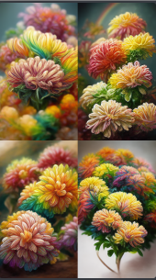

There is a kind of flower that is yellow. Its petals are as deep as sea water, and its heart is like dew. There are many green leaves on the branches, and many crystal yellow button chrysanthemums. You can feel its loyalty and purity in comparison with love.HD --ar 9:16

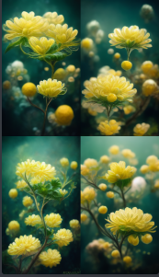

A dreamy picture in pale green, set in a green forest, with a cabin in the center, Small and delicate, colorful flowers bloom around the cabin. White clouds in the air are as fluffy and soft as cotton. Animated, cute, dreamy, 8K, three-dimensional. It was painted by Makoto Shinkai and Ghibli HD --ar 9:16

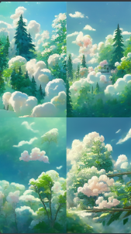

https://s.mj.run/zACiIO5zuLY PromptA's ultra-realistic CG rendering of ancient China. There is a stream, and the ancient buildings in the south of the Yangtze River are on the edge of this stream. At night, maple trees have milky white leaves, snow scenes, and the moon in the sky --ar 9:16

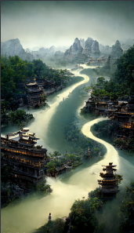

Fantasy, fairy flying to the moon Mid-Autumn Festival Chinese elegant flowers+tranquility+aestheticism+high details, soft moonlight, soft colors, soft lights, 8k new happiness, deep details, distinct levels of detail, high picture quality, high definition and new Huan Rendering --ar 9:16

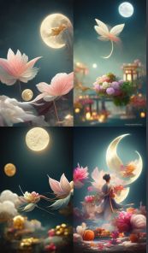

https://s.mj.run/Ufhkxf5g5Rk Cotton Candy House, Clouds of Love, Some Watermelons, Colorful Sunshine by Dennis schinick, Art Station Trend, Little Girls and Boys Playing, C4d, 8K, Ultra Wide Shot, Fairy Tale, Candy House, Crystal Palace by Kuno Veeber, Flyers, Sunshine, Trending on artstation,C4d,8K,Ultra Wide Angle,Fairy Tale,Candy House,Marshmallow Cloud,Rainbow,3DUnity,FHD, --ar 9:16 - Upscaled by

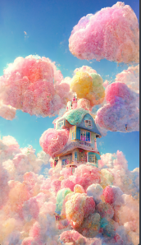

Fairyland on earth, Island in the lake, colorful, vegetation, beatiful light,Greg Rutkowski, unreal engine, Artstation HD --ar 9

: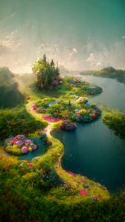16

https://i.mj.run/fcdd1d37-d73b-46e0-999d-6bd905167cfb/0_0.png The golden giant multicolored dragon and Phoenix are flying in The air, and The ground is colorful auspicious clouds, auspicious, healthy, dreamy, sci-fi, HD-ar 9:16, majestic and magical, wide-angle lens, super-realistic, Octane rendering, layering, HD, photography, colorfulclouds, HD --ar 9:16

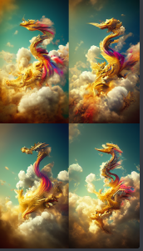

Dream and fairy flying moon Chinese style elegance, peach blossom + quiet + beautiful + high details, soft moonlight, Jade Rabbit, soft colors, soft lighting, 8K new happiness, deep details, clear layers, high quality, high definition and new love rendering HD--hd --ar 9:16

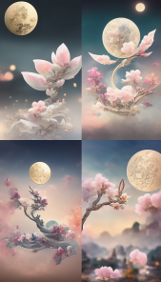

At the seaside, I want to see the scenery, want to chase the wind on the mountain, see the dusk and dawn, 3D, beautiful roses blooming on the sunset road, there are other shore flowers blooming, CG rendering, super realistic style description, dream, beautiful and romantic style, transparent ribbons floating in the air--hd --ar 9:16

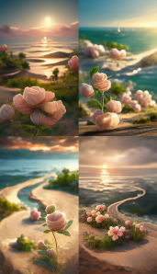

https://i.mj.run/2dadc22c-d335-49ec-a761-2a4f1bf57c89/0_3.png Dream and fairy flying moon Chinese style elegance, peach blossom + quiet + beautiful + high details, soft moonlight, Jade Rabbit, soft colors, soft lighting, 8K new happiness, deep details, clear layers, high quality, high definition and new love rendering HD--hd --ar 9:16

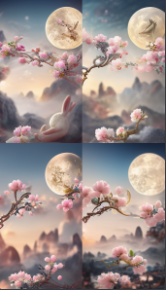

The beaches of Maldives have lots of pink roses, fluorescent sea, blue sky, panoramic,the breath of spring, soft sunlight, crystal dew, the sense of nature, Like crystal beads,feel the maximum detail; Lifelike is also based on Augmented Reality technology, 8K, HD --ar 9:16

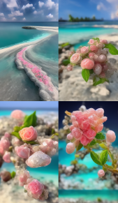

Picture is transparent, summer, sunny, rainbow, beach in Maldives with many pink and blue roses, silver sand, transparent foam, bright color scheme, surreal, fine detail, super clear, unreal engine, super Wide Angle, 4K HD, --ar 9:16

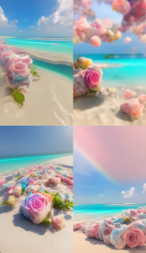

Picture is transparent, summer, sunny, rainbow, beach in Maldives with many pink and blue roses, silver sand, transparent foam, bright color scheme, surreal, fine detail, super clear, unreal engine, super Wide Angle, 4K HD, --ar 9:16

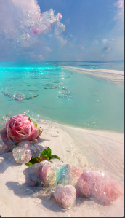

has a pink button Pom. Crystal clear, petals as deep as the sea water, crystal like dew, there are many green leaves with dew, many clear pink buttons, it can feel the loyalty and purity of loveHD --ar 9:16

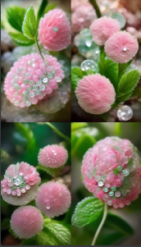

Blue ocean, snow covered beach, coupled color roses on the long beach, flashing flame light, the Milky Way shining many tiny and colorful Rose crystals, Arctic, tundra, iceberg, fantasy, high detail, beauty, 8K, octane rendering, realism, complex details, ultra wide angle of view, panoramic shooting,8k --ar 9:16

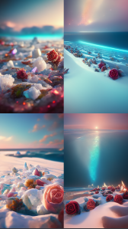

Blue ocean, snow covered beach, coupled color roses on the long beach, flashing flame light, the Milky Way shining many tiny and colorful Rose crystals, Arctic, tundra, iceberg, fantasy, high detail, beauty, 8K, octane rendering, realism, complex details, ultra wide angle of view, panoramic shooting,8k --ar 9:16

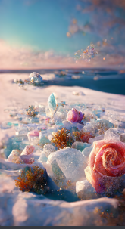

Blue ocean, snow covered beach, coupled color roses on the long beach, flashing flame light, the Milky Way shining many tiny and colorful Rose crystals, Arctic, tundra, iceberg, fantasy, high detail, beauty, 8K, octane rendering, realism, complex details, ultra wide angle of view, panoramic shooting,8k --ar 9:16

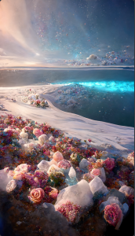

There is a bright moon on the sea, a romantic sea of flowers on the sea, high definition，photographic --ar 9:16

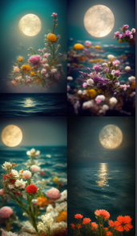

Moon, lanterns, flowers, 4K HD，photographic --ar 9:16

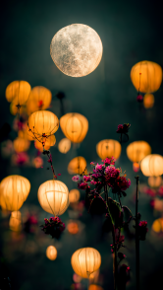

https://s.mj.run/88GLKfPGpnU There is a bright moon on the sea, a romantic sea of flowers on the sea, high definition，photographic --ar 9:16

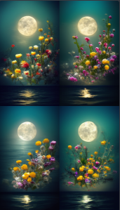

Gorgeous crystal palace, CG rendering European style, overlooking, fairy tale, rose surround, lighting effect, heavenly, starry sky, super detail, illustration, 4K, unreal engine, ethereal cloud, HD --ar 9:16

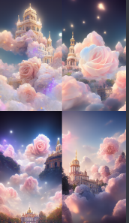

a painting of a castle surrounded by trees, a detailed matte painting by Mike Winkelmann, shutterstock contest winner, fantasy art, hall of mirrors, matte painting, matte drawing,The whole picture is the color of autumn,8K,UE4,HD, --ar 9:16

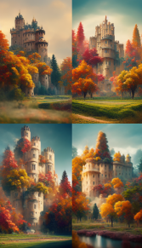

Cotton Candy House, Clouds of Love, Some Watermelons, Colorful Sunshine by Dennis schinick, Art Station Trend, Little Girls and Boys Playing, C4d, 8K, Ultra Wide Shot, Fairy Tale, Candy House, Crystal Palace by Kuno Veeber, Flyers, Sunshine, Trending on artstation,C4d,8K,Ultra Wide Angle,Fairy Tale,Candy House,Marshmallow Cloud,Rainbow,3DUnity,FHD, --ar 9:16

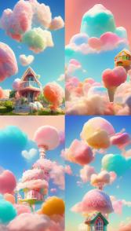

expansive view, In winter, there was an ice castle,Icy roses grew at the foot of the castle,by Thomas kinkade,artstation 4k --ar 9:16

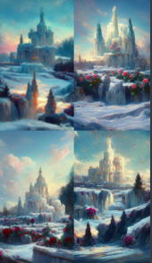

https://s.mj.run/ZLZPB5BWFP0 ,overlooking, fairy tales, surrounded by roses, dragons and phoenixes chasing the moon in the night sky, very beautiful, lighting effects, dreams, starry sky, super details, illustrations, 4K unreal engine, ethereal clouds HD 9:16K unreal engine, ethereal clouds,8K, HD --ar 9:16

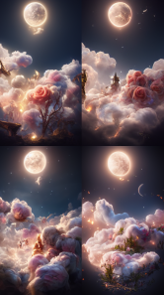

https://s.mj.run/4gGSj4Untbw ,overlooking, fairy tales, surrounded by roses, dragons and phoenixes chasing the moon in the night sky, very beautiful, lighting effects, dreams, starry sky, super details, illustrations, 4K unreal engine, ethereal clouds HD 9:16K unreal engine, ethereal clouds,8K, HD --ar 9:16

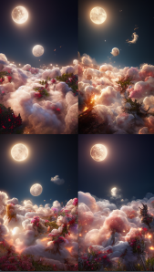

https://s.mj.run/UwO7yvgu8ko ,overlooking, fairy tales, dragons and phoenixes chasing the moon in the night sky, very beautiful, lighting effects, dreams, starry sky, super details, illustrations, 4K unreal engine, ethereal clouds HD 9:16K unreal engine, ethereal clouds,8K, HD --ar 9:16

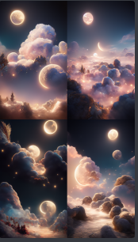

https://s.mj.run/UwO7yvgu8ko ,overlooking， fairy tales, dragons and phoenixes chasing the moon in the night sky, very beautiful, lighting effects, dreams, starry sky, super details, The reflection of the river，illustrations, 4K unreal engine, ethereal clouds HD 9:16K unreal engine, ethereal clouds,8K, HD --ar 9:16

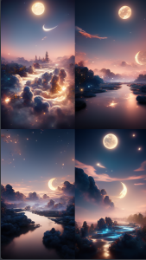

https://s.mj.run/-x098NhFgTc ,overlooking， fairy tales, dragons and phoenixes chasing the moon in the night sky, ,The reflection of the riververy beautiful, lighting effects, dreams, starry sky, super details,illustrations, 4K unreal engine, ethereal clouds engine, ethereal clouds,8K, HD --ar 9:16

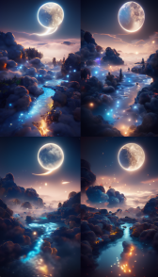

Gorgeous crystal palace, CG rendering European style, overlooking, fairy tale, rose surround, lighting effect, heavenly, starry sky, super detail, illustration, 4K, unreal engine, ethereal cloud, HD --ar 9:16

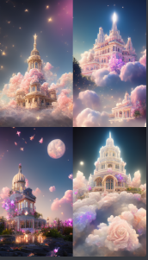

A beautiful painting of Miyazaki Hayao, in which there are many lovely green houses, surrounded by all kinds of flowers, green leaves and soft clouds. It is very healing and the picture is simple, by Makoto shinkai and Thomas kinkade, Trending on artstation."--hd --ar 9:16

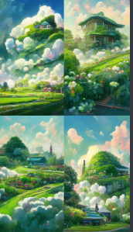

Gorgeous crystal palace, CG rendering European style, overlooking, fairy tale, rose surround, lighting effect, heavenly, starry sky, super detail, illustration, 4K, unreal engine, ethereal cloud, HD --ar 9:16

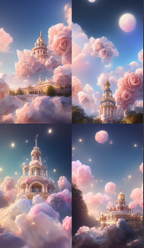

https://s.mj.run/Ufhkxf5g5Rk Cotton Candy House, Clouds of Love, Some Watermelons, Colorful Sunshine by Dennis schinick, Art Station Trend, Little Girls and Boys Playing, C4d, 8K, Ultra Wide Shot, Fairy Tale, Candy House, Crystal Palace by Kuno Veeber, Flyers, Sunshine, Trending on artstation,C4d,8K,Ultra Wide Angle,Fairy Tale,Candy House,Marshmallow Cloud,Rainbow,3DUnity,FHD, --ar 9:16 --q 2

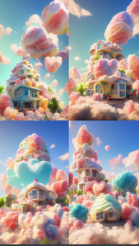

https://s.mj.run/tjkU2SQzK6E A stunning picture of Heavenly palace Wonderland, surrounded by a sea of clouds, the palace has rainbow, waterfall effect, elevation map, wide-angle lens, ultra-realistic, octane rendering, hierarchical, ultra-real, CG rendering, powerful visual effects, HD,8K. redshift rendering, 16K. angle,3D cut_ic_pow=[25].HD,--hd --ar 9:16

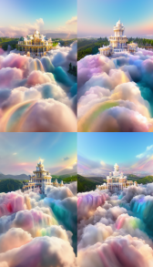

https://s.mj.run/UlAYX7ZLf9g A panoramic sky garden rose world in a special-shaped transparent glass bottle, castle, roses, petals are flying, romance, dream, Greg lat Kosky, night, red rose Pavilion, art station trend, bright lights, smoke, wood support, UE4, HD, lighting, winter, AUV --ar9:16

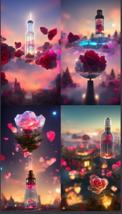

Magnificent golden Chinese palace CG rendering Chinese style, overlooking, fairy tales, surrounded by roses, lighting effects, dreams, starry sky, super details, illustration, 4K, illusory engine, ethereal clouds, art - HD --ar 9:16

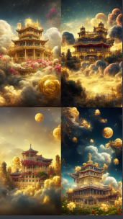

https://s.mj.run/rjNRy6cksdU sakura笔触，朦胧美，在空中飞舞，海天一色，unripe with dreamy color lighting effect Ultra-fine, ultra-clear, ultra-wide angleHD 8k, --ar 9:16

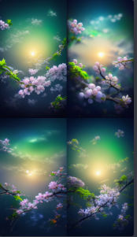

https://s.mj.run/8tGvA9nSz40 /Classic Chinese Town, Festival, Super Moon Night, Fireworks, Arch Bridge, Stream, Rich Color, Super Clear, Movie Scene, Panoramic Shot, Perfect Composition, Super Fine, Perfect Details, Super Delicate, Fantasy, Futurism, Unreal Engine 5, Photorealistic, HD, Art Station Trends, Concept Art, Post Production, 8k Rendering, 3d Film, Award Winning Photography,::3.1 --ar 9:16

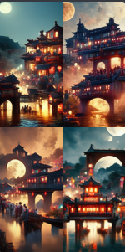

https://s.mj.run/KrbodTlKEMA Beautiful evening, super moon, full moon, beautiful scenery, Chinese architectural town, lanterns, arch bridge, creek, beautiful fireworks, colorful, super clear, sci-fi movie scene, panoramic shot, perfect, super fine, perfect detail, super detailed, fantasy, futuristic, Unreal Engine 5, photorealistic, art station trends, concept art, post production, HD，8k rendering, 3d film,, 3.2 moonlight, 1 Fluorescent, 1 candlelight, 1 360 panorama, 1 panorama, 1 --ar 9:16

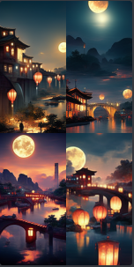

https://s.mj.run/KrbodTlKEMA Beautiful evening, super moon, full moon, beautiful scenery, Chinese architectural town, lanterns, arch bridge, creek, beautiful fireworks, colorful, super clear, sci-fi movie scene, panoramic shot, perfect, super fine, perfect detail, super detailed, fantasy, futuristic, Unreal Engine 5, photorealistic, art station trends, concept art, post production, HD，8k rendering, 3d film,, 3.2 moonlight, 1 Fluorescent, 1 candlelight, 1 360 panorama, 1 panorama, 1 --ar 9:16

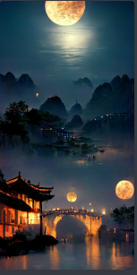

They still think that Atlantis never existed, except as a myth or an island destroyed by cataclysm HD --ar 9:16

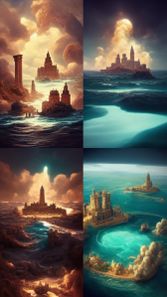

We went to the temple of Atlantis and saw it by moonlight HD --ar 9:16

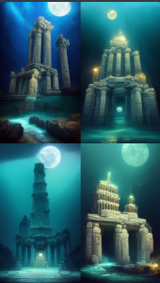

Atlantis blue sky, panoramic,the breath of spring, soft sunlight, crystal dew, the sense of nature, Like crystal beads,feel the maximum detail; Lifelike is also based on Augmented Reality technology, 8K, HD --ar 9:16

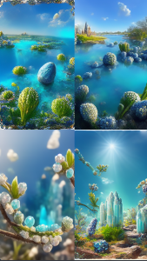

https://s.mj.run/brnWcmDWpaU Atlantis blue sky, panoramic,the breath of spring, soft sunlight, crystal dew, the sense of nature, Like crystal beads,feel the maximum detail; Lifelike is also based on Augmented Reality technology, 8K, HD --ar 9:16

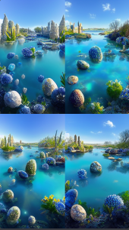

Atlantis ，blue sky, panoramic,the breath of spring, soft sunlight, crystal dew, the sense of nature, Like crystal beads,feel the maximum detail; Lifelike is also based on Augmented Reality technology, 8K, HD --ar 9:16

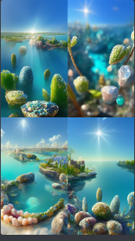

Atlantis ，blue sky, panoramic,the breath of spring, crystal dew, the sense of nature,feel the maximum detail; Lifelike is also based on Augmented Reality technology, 8K, HD --ar 9:16

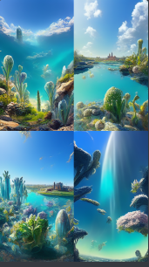

Dream and fairy flying moon Chinese elegant, the moon in the water, peach blossom + static + beauty + high details, soft moonlight, soft colors, soft lighting, 8K HD, many luminous examples illuminate the Milky Way, deep details, layered details, high quality, high definition and new love rendering HD--hd --ar 9:16（https://s.mj.run/f8c8Uv1SKoc）

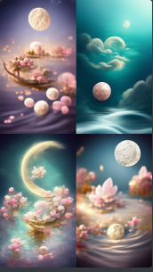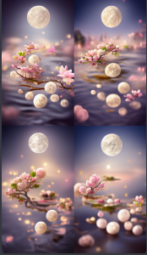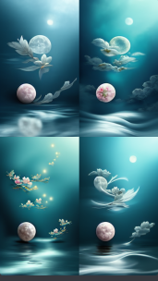

https://s.mj.run/ZY3ZRo6x1IA Dream and fairy flying moon Chinese elegant, the moon in the water, peach blossom + static + beauty + high details, soft moonlight, soft colors, soft lighting, 8K HD, many luminous examples illuminate the Milky Way, deep details, layered details, high quality, high definition and new love rendering HD--hd --ar 9:16

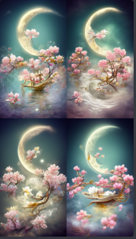

A beautiful painting of Miyazaki Hayao, in which there are many lovely green houses, surrounded by all kinds of flowers, green leaves and soft clouds. It is very healing and the picture is simple, by Makoto shinkai and Thomas kinkade, Trending on artstation."--hd --ar 9:16

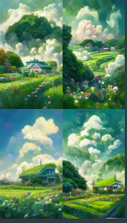

Blue background, crystal clear crystal castle. Gorgeous Crystal Palace, CG rendering European style, surrounded by pink roses, real flowers, overlooking, fairy tale, lighting effects, starry sky, super detail, illustration, 4K, Unreal Engine, ethereal clouds,--hd --ar 9:16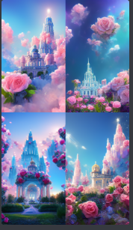

Magnificent glowing Chinese palace CG rendering Chinese style, surrounded by peach blossom trees, Chang 'e flying to the moon, moon, starry sky, looking up at the map, wide- angle lens, ultra-realistic, octane rendering, layered, HD，photographic --ar

9:16

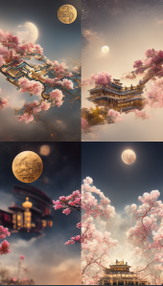

Blue background, crystal clear crystal castle. Gorgeous Crystal Palace, CG rendering European style, surrounded by pink roses, real flowers, overlooking, fairy tale, lighting effects, starry sky, super detail, illustration, 4K, Unreal Engine, ethereal clouds,--hd --ar 9:16

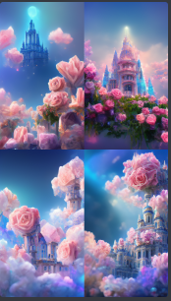

A beautiful painting of Miyazaki Hayao, in which there are many lovely green houses, surrounded by all kinds of flowers, green leaves and soft clouds. It is very healing and the picture is simple, by Makoto shinkai and Thomas kinkade, Trending on artstation."--hd --ar 9:16

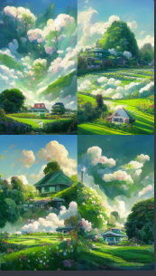

Dream and fairy flying moon Chinese style elegance, lotus + quiet + beautiful + high details, soft moonlight, soft colors, soft lighting, 8K new happiness, deep details, clear layers, high quality, high definition and new love rendering HD--hd --ar 9:16

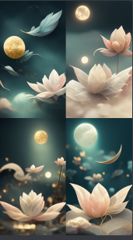

Gorgeous Crystal Palace, CG rendered European style, bird view, fairy tale, rose surround, lighting effects, sky, starry sky, super detail, illustration, 8K,4K, Unreal Engine, ethereal clouds are heart shaped, fantasy, HD--hd --ar 9:16

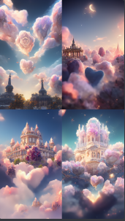

Gorgeous Crystal Palace, CG rendering European style, overlooking, fairy tale, rose surround, lighting effects, Heaven, starry sky, super detail, illustration, 8K, 4K, Unreal Engine, ethereal clouds, fantasy, HD--hd --ar 9:16

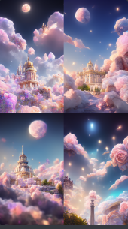

mystical city in the trees, massive city built in the trees, stunning, magical, photorealistic, dramatic lighting, 85mm prime lens, highly detailed —ar 9:16

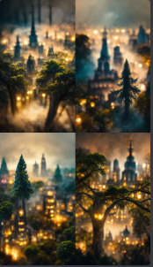

https://s.mj.run/zY7p31B-oy4 a village in Cherry Blossom valley in Japan, cherry blossom petals are falling, Makoto Shinkai style, hyper detailed, hyper quality, 8k, HD --ar 9:16

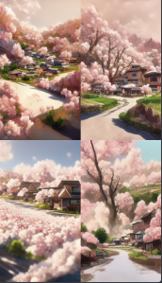

**<https://s.mj.run/SlmONptlFU8> There is a flower is the blue anemone, its petals are transparent, as deep as the sea, as crystal clear as dew, it can feel the loyalty and purity of love, 8K, HD--hd --ar 9:16

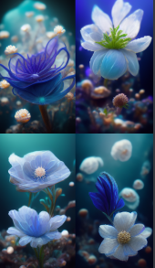

**Blue background, crystal clear crystal castle. Gorgeous Crystal Palace, CG rendering European style, surrounded by pink roses, real flowers, overlooking, fairy tale, lighting effects, starry sky, super detail, illustration, 8K, Unreal Engine, ethereal clouds,--hd --ar 9:16

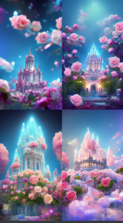

**Surreal CG rendering of the Mid-Autumn Festival, there is a Jiangnan ancient architectural style of the stream, at night, lanterns, there are the moon, meteor, stars, 8K high-definition flow, 8k, render, Detail, Octane Render, Extreme, Detail, HD --ar 9:16

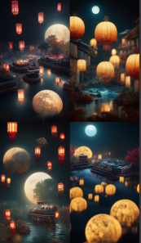

**<https://s.mj.run/L877_h7AF6o> << Holy Light White Butterfly Angel, blooming flowers, pastel colors, white, union, flowing, pink, beige, surreal, painting, ethereal, --ar 9:16

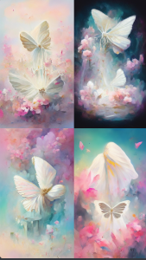

**A beautiful picture painted by Makoto Shinkai, with many lovely green fairy tale huts, surrounded by various flowers, green leaves and soft clouds, is very healing, and the picture is simple and clean lighting effects, 3 d effect, CG， super wide Angle, 8 k, quality fashion art station, covered in sparkling fog, twinkling stars, marmosets suit --ar 9:16

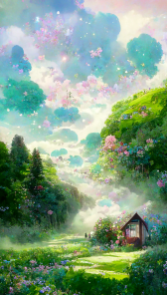

**<https://s.mj.run/SlmONptlFU8> There is a flower is the blue anemone, its petals are transparent, as deep as the sea, as crystal clear as dew, it can feel the loyalty and purity of love,8K, HD--hd --ar 9:16

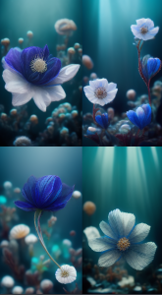

**Dreams and fairies fly to the Moon Mid-Autumn Festival Chinese elegant white lotus + serenity + aestheticism + high detail, soft moonlight, soft colors, soft lighting, 8k new happiness, deep details, layered details, high quality, high definition and new love rendering HD --ar

9:16

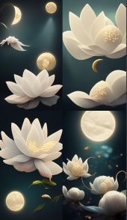

Beautiful jasmine floating in the air, petals curled, surrounded by bright pollen, the breath of spring, soft sunlight, crystal dew, the sense of nature, feel the maximum detail; Lifelike is also based on Augmented Reality technology, 4K, HD --ar 9:16

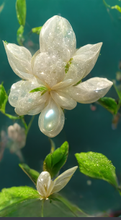

Farmhouse, full of roses in the yard, rainbow clouds, chickens in the front door, ducks in the back door, a large area of roses, glowing fireflies, dream home, petals flying, moon, night, cool wind in front of the door, HD, 8K, romantic, light,8k --ar 9:16

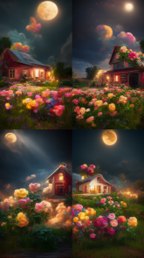

https://s.mj.run/A4F48vN8rRc In a forest, there is a magical castle. Roses climb all over the walls. The stars and the moon shine in the sky. Rainbow clouds, a large area of roses, glowing fireflies, dream homes, petals flying, moon, night, cool wind blowing in front of the door, HD, 8K, romantic, light, crystal clear, bright, feel the greatest details,8k --ar 9:16

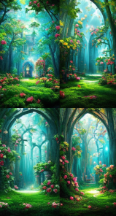

Blue ocean, snow covered beach, coupled color roses on the long beach, flashing flame light, the Milky Way shining many tiny and colorful Rose crystals, Arctic, tundra, iceberg, fantasy, high detail, beauty, 8K, octane rendering, realism, complex details, ultra wide angle of view, panoramic shooting,8k --ar 9:16

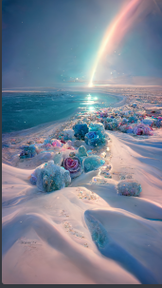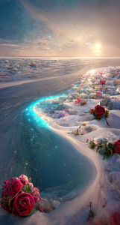

Blue ocean, snow covered beach, coupled color roses on the long beach, flashing flame light, the Milky Way shining many tiny and colorful Rose crystals, Arctic, tundra, iceberg, fantasy, high detail, beauty, 8K, octane rendering, realism, complex details, ultra wide angle of view, panoramic shooting,8k --ar 9:16

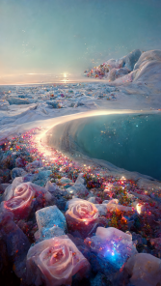

<https://s.mj.run/WPgZxPJ1xd4> has a pink button Pom. Crystal clear, petals as deep as the sea water, crystal like dew, there are many green leaves with dew, many clear pink buttons, it can feel the loyalty and purity of loveHD --ar 9:16

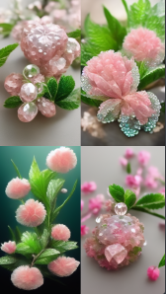

Gorgeous Crystal Palace, CG rendered European style, bird view, fairy tale, rose surround, lighting effects, sky, starry sky, super detail, illustration, 8K,4K, Unreal Engine, ethereal clouds are heart shaped, fantasy, HD--hd --ar 9:16

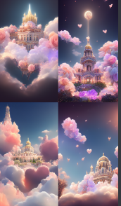

Gorgeous Crystal Palace, CG rendering European style, bird's eye view, fairy tale, rose surround, lighting, sky, starry sky, super detail, illustration, 8K,4K, Unreal Engine, ethereal clouds are heart shaped, fantasy, HD,--hd --ar 9:16

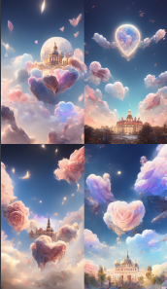

Dream and fairy flying moon Chinese style elegance, peach blossom + quiet + beautiful + high details, soft moonlight, Jade Rabbit, soft colors, soft lighting, 8K new happiness, deep details, clear layers, high quality, high definition and new love rendering HD--hd --ar 9:16

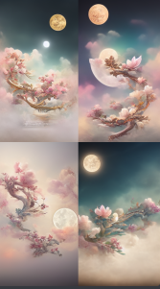

Animated small spirit Fox, DND characters, Background focus, Fantasy, Magic, Realistic textured skin, clear and clean, by Lya Kushinov, Avetezuya Studio, Alexandra Fomina ARtSTATION, Makoto Shinkai, Digital 2D, Radiance Painting

Harry,

To speed up

8 k HD picture--hd --ar 9:16

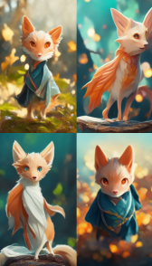

Dream and fairy flying moon Chinese style elegance, peach blossom + quiet + beautiful + high details, soft moonlight, Jade Rabbit, soft colors, soft lighting, 8K new happiness, deep details, clear layers, high quality, high definition and new love rendering HD--hd --ar 9:16

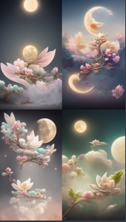

A spectacular waterfall, surrounded by roses, mysterious, bright, twinkling stars, movie lights, photorealistic, overlooking, high detail, surreal, mysterious, 8K, HD--hd --ar 9:16

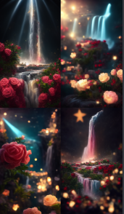

Dream and fairy flying moon Chinese style elegance, peach blossom + quiet + beautiful + high details, soft moonlight, Jade Rabbit, soft colors, soft lighting, 8K new happiness, deep details, clear layers, high quality, high definition and new love rendering HD--hd --ar 9:16

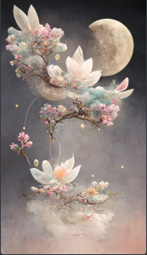

A beautiful picture depicts a train surrounded by pale pink roses. Lighting effects, on the top of the train has a lot of light blue roses, there are white clouds, the sky of soft cloud, rainbow and sunshine, hayao miyazaki painting, lifelike, fashion art, CG rendering, 8 k high definition, beautiful paradise, the 3 d effect, aesthetic illustrations, film aesthetics effect, crystal lamp, the AUV, 4 k post processing in detail, art, rendering by octane, Unreal Engine - Mass 1.5--hd --ar 9:16

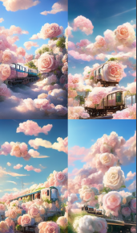

https://s.mj.run/BENV9PWny9E Bottom view, the scenery of the mysterious peach blossom forest, the peach blossoms are in full bloom, the sun shines through the fog,HD --ar 9:16

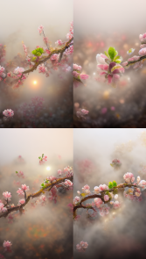

The mysterious forest scenery, the sun shines through the fog, the peach blossoms are in full bloom, the petals are as deep as sea water, and the heart is like dew. There are many green leaves on the branches,HD --ar 9:16

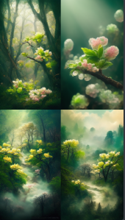

The peach blossoms are in full bloom, the sun shines through the mist and white clouds, the petals are as deep as sea water, and the heart is as dew. There are many green leaves on the branches, and many crystal clear water droplets. HD --ar 9:16

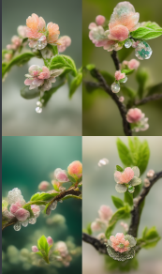

There is a flower that is red. The petals are as deep as sea water, and the heart is as dew. There are many green leaves on the branches, and many crystal clear white button daisies. Compared with love, you can feel its loyalty and purity. HD --ar 9:16

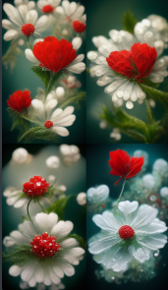

Rich chrysanthemum,gentle moonlight,scented osmanthus,beautiful scenethisis the Mid-Mid-Autumn festival colorful basket.lt is permeated with cheerful rhythm,floating with happy notesflowimg sweet smile revealing love thoughts,wish such a festival,the whole world to share.hyperrealism HD --ar 9:16

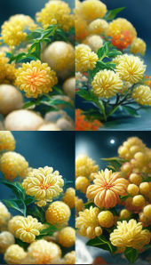

https://s.mj.run/ctNKBviN9mA Luxurious palace, lighting, beautiful roses in front, crystal rose garden, ice blue leaves, layered, magic, realism, super detail, lifelike, 8K, 16K resolution, masterpiece, functional art station, octane rendering, panoramic, wide Angle, 3D, ice blue rendering, super realistic,--hd --ar 9:16

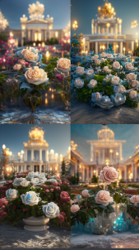

https://s.mj.run/cs8CRpR8hdw Ancient magical forest, tall pink trees, moonlit, with bioluminescent mushrooms,rose paths,crystal clear and self-luminous,fireflies, pale blue fog. mysterious, twinkling stars, cinematic lighting, photorealism,high details, hyper realistic,mysterious, 8k, wide angle, HD --ar 9:16

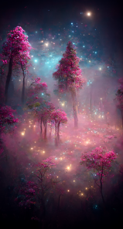

Huge castle, surrounded by pink peony flowers, sky, shooting stars, firefly dots, panoramic, wide Angle, super detail, super realistic, transparent 8K, 16K resolution, 3D, octane rendering, super realistic, --hd --ar 9:16

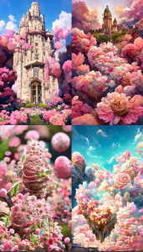

An epic CG matte painting , expansive view , pale green clouds,Disney Castle with a garden full of flowers on the clouds , several waterfulls drops from the clouds , A sea of pale green roses , by Zeen Chin , high - definition picture , Unreal Engine , Trending on artstation --hd --ar 9:16

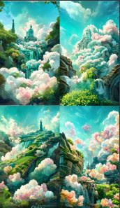

Green fairy tale cabin, surrounded by flowers around a variety of colorful flowers, bushes, muddy trails, smoke, early morning, panoramic, wide Angle, ultra detail, ultra realistic, 8K, 16K resolution,3D, octane rendering, ultra realistic, ultra HD,--hd --ar 9:16

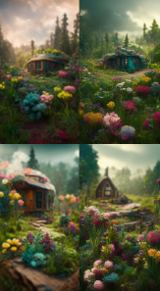

**In the morning, the green forest, full of flowers, in the middle of the Blue roses of different sizes, there are many water beads on the roses, around the starlight like butterflies, Miyazaki Hayao painting style, macro shooting, lighting effect, realistic, 4K, HD --ar 9:16

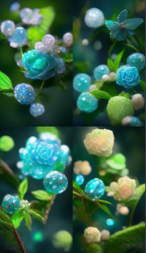

A beautiful picture depicts a pale green fairy tale world, a strawberry hut and a fairyland of white smoke. Lighting effect, cotton around the house, floating mist and roses around, Miyazaki Hayao's animation is still feeling, pastoral style, very detailed rendering style, 4k detailed post-processing, art station, rendering by octane, illusory engine --ar 9:16

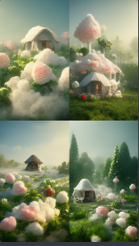

Green fairy castle, lights around, colorful flowers, shrubs, smoke, mountains, smoke, morning after rain, panoramic, forward view, super detail, super realistic, 8K, 16K resolution, 3D, octane rendering, super realistic, ultra HD,--hd --ar 9:16

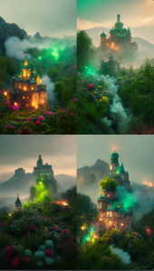

Under the hazy moonlight, there are several colorful flowers nearby. There are many crystal clear dew on the transparent petals, which are blooming on the bank. There is a winding and clear stream, and the valley in the distance is surrounded by clouds，HD --ar 9:16

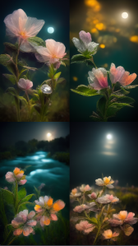

**By new haicheng painted a beautiful picture, there are many lovely green fairy tale hut, is surrounded by various kinds of flowers, leaves and soft cloud, very has a therapeutic effect, simple picture clean lighting effects, 3 d effect, CG, ultra wide Angle, 8 k, high quality fashion art station, covered in sparkling fog, twinkling stars, fusion suits，--hd --ar 9:16

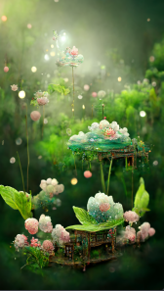

https://s.mj.run/lLXVJWDrnKA a beautiful picture. There are many huge blue roses floating in the deep sea, the brightness of the moon, magic clouds, several sailboats, giant sailboats, Klein Blue Dream rendering, surreal, surreal, super beautiful dream, HD,beautiful ethereal fairyland--hd --ar 9:16

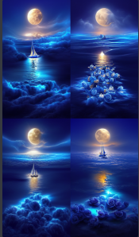

https://s.mj.run/Pjcspzb8GEs Holy light white angel, angel light effect, light,wings, blooming flowers, flow. ethereal, surreal, --ar 9:16

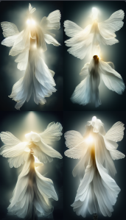

Two luminous butterflies, gray background, huge moon, snowflakes flying, like a dream, high-definition, realistic, detailed, realistic, 3D, 8K,--hd --ar 9:16

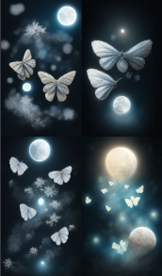

Magnificent golden Chinese palace CG rendered Chinese style, overlooking, fairy tale, surrounded by roses, lighting effects, dreams, stars, super detail, illustrations, 4K, Unreal Engine, ethereal clouds, HD--hd --ar 9:16

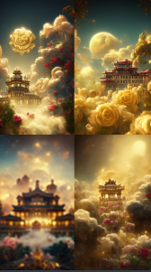

https://s.mj.run/c8mZxpAekWk Cotton Candy House, Clouds of Love, Some Watermelons, Colorful Sunshine by Dennis schinick, Art Station Trend, Little Girls and Boys Playing, C4d, 8K, Ultra Wide Shot, Fairy Tale, Candy House, Crystal Palace by Kuno Veeber, Flyers, Sunshine, Trending on artstation,C4d,8K,Ultra Wide Angle,Fairy Tale,Candy House,Marshmallow Cloud,Rainbow,3DUnity,FHD, --ar 9:16 --q 2

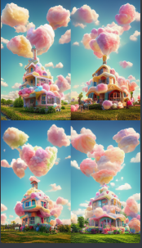

Waterfalls, flowers, trees, HD，photographic --ar 9:16

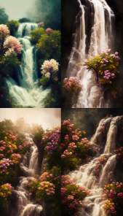

https://i.mj.run/add70e32-e6c4-409a-8d35-5167406b85b6/0_0.png Luxurious palace, lighting, beautiful roses in front, crystal rose garden, ice blue leaves, layered, magic, realism, super detail, lifelike, 8K, 16K resolution, masterpiece, functional art station, octane rendering, panoramic, wide Angle, 3D, ice blue rendering, super realistic,--hd --ar 9:16

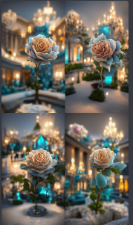

Fairyland on earth, Island in the lake, colorful, vegetation, beatiful light,Greg Rutkowski, unreal engine, Artstation HD --ar 9:16

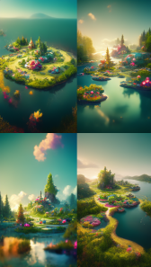

Close-up of the foreground, the bottle is round, there is a starry sky in the bottle, there is a Money Tree, and they are all sparkling. Bokeh, light blue sky, full moon, Pegasus star map, beautiful, dreamy, space art, extreme detail, ultra wide-angle lens, 8K, ultra clear, Unreal Engine, lightpainting, Octane rendering, --ar 9:16 --s 5000

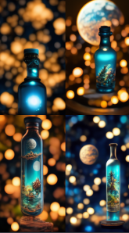

https://s.mj.run/oYeqdOeR_c4 A stunning picture of Heavenly palace Wonderland, surrounded by a sea of clouds, the palace has rainbow, waterfall effect, elevation map, wide-angle lens, ultra-realistic, octane rendering, hierarchical, ultra-real, CG rendering, powerful visual effects, HD,8K. redshift rendering, 16K. angle,3D cut_ic_pow=[25].HD,--hd --ar 9:16

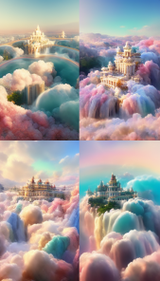

Magnificent golden Chinese palace CG rendering Chinese style, overlooking, fairy tales, surrounded by roses, lighting effects, dreams, starry sky, super details, illustration, 4K, illusory engine, ethereal clouds, art - HD --ar 9:16

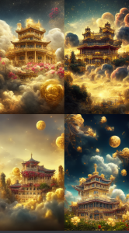

There were many thin branches and little flowers floating in the deep blue sky,light fog in the air, high definition, dreaming of the kingdom of elves HD --ar 9:16

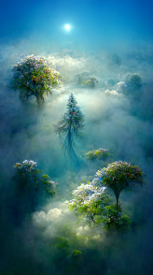

a childrens fantasy book hobbit house in a tree covered by moss, flowers and mushrooms by jeremy mann and greg --ar 9:16

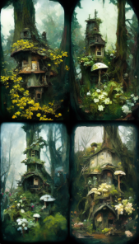

Oriental Myth , Chinese dream Dunong

Huang Feitian , HD cG , Phoenix , cloud ,

golden Chinesc palacc , flamc , HD , cxquisitc crystal noble and gorgeous Tulle light

clothes , behind which are a pair of

translucent and gorgeous white wings , soft golden light , golden flying feather , golden feather , mystery , gem , smoke , film HD , many details , surrcalism , magic , u fantasy cngine , lighting --ar 9:16

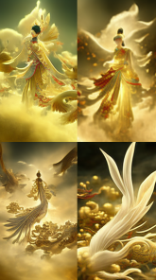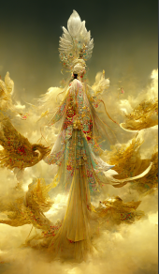

Oriental myth , Chinese dream Dununhuang Flying sky , super delicate , crystal noble

Gorgeous tulle light clothes , behind a pair of translucent gorgeous white wings , soft light , gold wirvire Flying , white feathers , mystery , gems , smoke , Movie HD , lots of detail ,

surrealism , magic , UUnreal Engine , lighting --ar 9:16

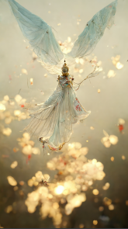

Baroque style, holy light white angel, angel's light effect, light, wings, blooming flowers, flow. Ethereal, surreal, film shooting, mystery, fantasy, 8K HD,HD. --ar 9:16

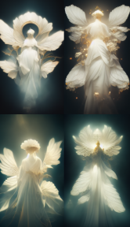

Baroque style, oriental mythology, Chinese dream Dunong Huang Feitian, ultra-delicate, crystal-noble and gorgeous tulle light clothes, behind which is a pair of translucent and gorgeous white wings, huge moon, Chinese palace, soft lights, golden flying feathers, white feathers, mystery, gems, smoke, movie HD, many details, surrealism, magic, U unreal engine, lighting.HD. --ar 9:16

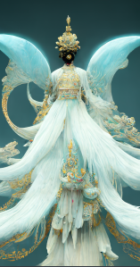

Christian Dahl, baroque style, it's a beautiful beach, colorful starfish on the beach, conch, night, starlight, crescent moon, blue water, dreamy, super wide-angle shot, Unreal Engine, 4K HD, , HD .HD. --ar 9:16

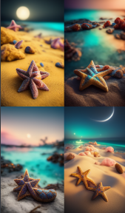

surreal render painting of Chinese town of Song dynasty,milky way,lively, festival,sky lanterns, Osmanthus fragrans,gentle and light colors,cinematic lighting,expansive view,ultrawide shot,8k, --ar 9:16

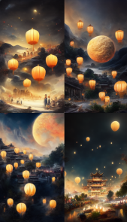

surreal render painting of Chinese town of Song dynasty,milky way,lively, festival,sky lanterns, Osmanthus fragrans,gentle and light colors,cinematic lighting,expansive view,ultrawide shot,8k, --ar 9:16

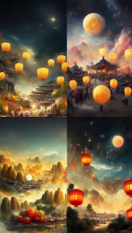

A luminous crystal in the dark rose forest. There are luminous ovules and lava crystals of ginger and blue roses on the rose path. It is fascinated by the blizzard style artstation trend, magical light fog, night time, low light, volume lighting, UE4, ZBrush, marmoset toolkit ，8k --ar 9:16

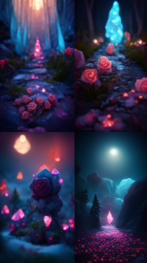

Beautiful Yipu Garden, luminous transparent crystal path, pale pink and golden yellow roses, cherry trees, cute animals in anthropomorphic state, warm pale pink translucent sunshine, super clear,Realistic photos,Warm color matching,Fine details,Ultra-wide angle lens,4k HD --ar 9:16

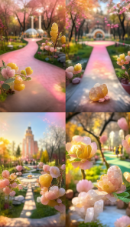

Beautiful Yipu Garden, luminous transparent crystal path, pale pink and golden yellow roses, cherry trees, cute animals in anthropomorphic state, warm pale pink translucent sunshine, super clear,Realistic photos,Warm color matching,Fine details,Ultra-wide angle lens,4k HD --ar 9:16 --iw 10 --q 2

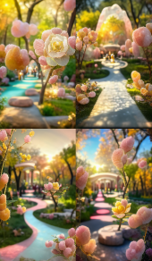

A huge hanging garden with a panoramic view, the Red Rose Garden, is in the princess's room and in a tall castle,frozen twigs,Many wooden frames, snow, bush,candle lighting, Greg latter Kosky. night, little red rose pergola, frozen red rose,art station trend, bright light, smoke, wooden stand, UE4,HD, --ar 9:16

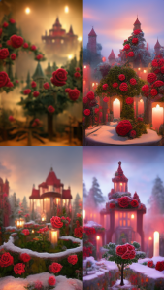

A huge hanging garden with a panoramic view, the Red Rose Garden, is in the princess's room and in a tall castle,frozen twigs,Many wooden frames, snow, bush,candle lighting, Greg latter Kosky. night, little red rose pergola, frozen red rose,art station trend, bright light, smoke, wooden stand, UE4,HD, --ar 9:16

The city of Kyoto 1000 years ago at night,with many cherry blossoms in full bloom, petals floating in the sky, in the style of studio ghibi, 8k --aspect 16:9

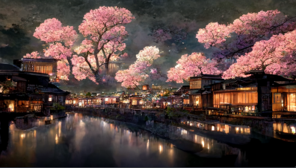

beautiful European girl emerging from the water, wet hair, lilypads, shaded vector art by lois van baarle, artgerm, Helen huang, by makoto shinkai and ilya kuvshinov, rossdraws, illustration, art by ilya kuvshinov --ar 3:5 --testp --testp --upbeta --upbeta

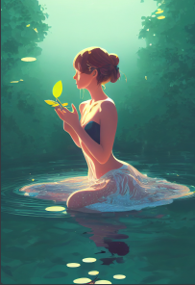

Pixar Style, Tiny cute and adorable snow tiger adventurer dressed in fantasy armour , jean - baptiste monge , anthropomorphic , dramatic lighting, 8k, portrait, --ar 9:16 --s 5000 --testp --upbeta --upbeta --upbeta --upbeta



Pixar's cute little rabbit,big eyes and long ears,wearing armor like a spartan warrior in the snow,front view,very detailed,3D,very realistic,volume lighting,epic lighting,movies,high resolution,8k --testp --ar 9:16



Pixar style A cute and adorable baby white rabbit a big fluffy tail,holding a pink flower lay on a cloud in paradise,big eyes,Peach blossom,stream,enchanting,immortal,fluffy,shiny mane,Petals,fairyism,unreal engine 5 and Octane Render,high resolution,8k --testp --ar 9:16

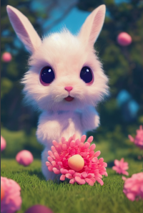

character design, Pixar style, tiny cute and adorable lama, shades of blue, anthropomorphic, dramatic lighting,8k, --ar 9:16

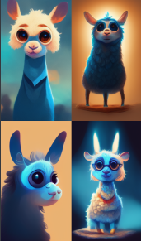

interior scene, studio ghibli, magical study room, solarpunk，octane render，8k, --ar 9:16

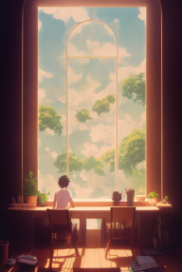

Interior Scene, Studio Ghibli, Enchanted Den, Lush Greenery, Solar Punk, Intricate Detail, Concept Art, Photorealistic, Volumetric Lighting, Octane Render, 8k, --ar 9:16

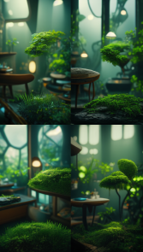

Ancient Chinese buildings above dreamy colorful clouds with galaxy moon above, Hayao Miyazaki, anime, gaming, hyperreal, octane rendering, photorealistic, intricate details, 16K, high resolution, vivid colors Unreal Engine --ar 9:16

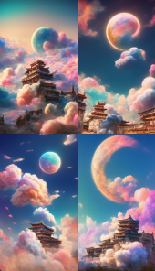

Enchanted Walled Garden with Greenhouse, Alice in Wonderland Style Manga, Hayao Miyazaki --ar 9:16

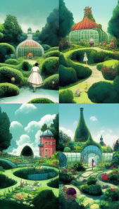

Milky way sky with dense glowing river water under the moonlight, lots of glowing small rubble, lots of glowing alien plants, photography, --ar 9:16

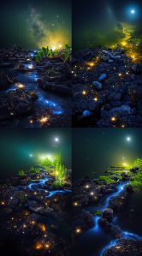

The path extends to the fantasy forest, with purple flowers beside the road and fireflies in the forest, 16K, photography, --ar 9:16

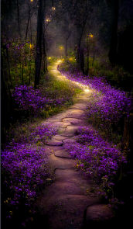

A galaxy at the center of a colored crystal, super complex, unique, super detailed, some mirrored elements, 8k, some filigree, octane rendering, HDR, 4k, --ar 9:16

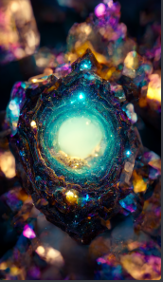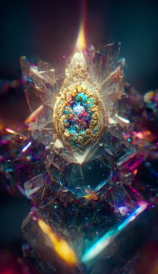

interior, Arrietty’s Bedroom, lush plants, pixie home, home of little people, fairytale, vintage, homey, decorated,

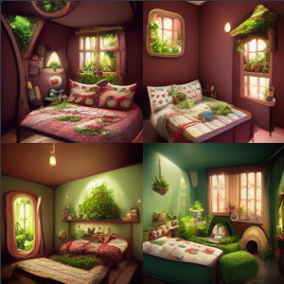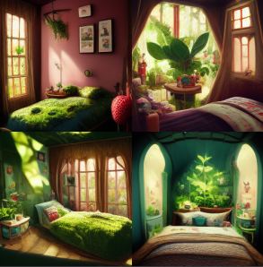

grand scene, blue glowing water, super pink crystal roses on white sand, moon, galaxy, super detailed, epic cinematic, photorealistic, unreal engine, octane rendering, HDR, 4k, --ar 9:16

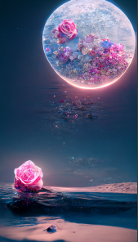

grand scene, blue glowing water, super frozen red roses on meandering white sand, moon, galaxy, super detailed, epic cinematic, photorealistic, unreal engine, octane rendering, HDR, 4k, --ar 9:16

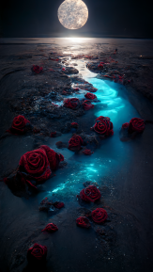

grand scene, super frozen pink roses on meandering ice, moon, galaxy, super detailed, epic cinematic, photorealistic, unreal engine, octane rendering, HDR, 4k, --ar 9:16

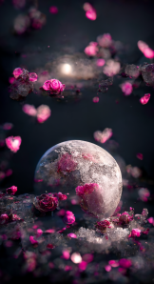

At night sky, the beach is covered with blue and yellow fluorescence the moon, elf light, stars, facula, the sea with --ar 9:16

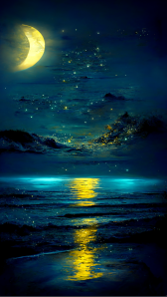

THE CHERRY BLOSSOM TREE HOUSE --ar 9:16

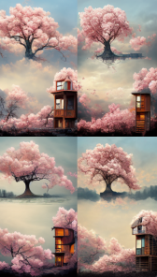

Gondola boat, lake surface, glow around boat, super detailed, galaxy, some mirrored elements, octane rendering, HDR, 4k --ar 9:16

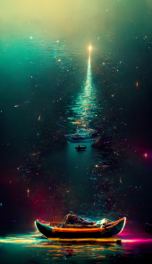

Gondola boat, lake surface, glow around boat, super detailed, galaxy, some mirrored elements, octane rendering, HDR, 4k --ar 9:16

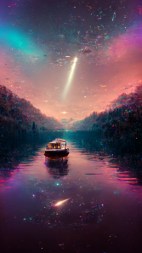

Super wide angle view, purple rose garden + beautiful paintings in the factory area, tall factory with many iron frames, iron nets, factory lighting, Greg ratkowski, night, a little purple rose on the iron frame, art station trend, low light, smoke, steel support, volume lighting, UE4, ZBrush, marmoset Kit HD --ar 9:16

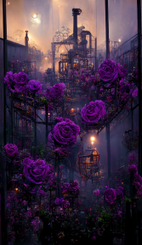

Lake surrounded by woods at night, galaxies in the sky reflected in the water, golden clouds, sunset red, unreal engine, super realistic, intricate details and rich colors dreamy, The sky is full of red clouds,super wide-angle light , Unreal Engine, The big moon,4K HD, , HD. --ar 9:16 --v 3

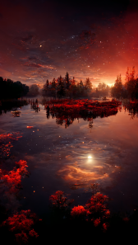

A cute and cute little brown rabbit with long ears, wearing a denim sling coat, a plaid shirt, carrying a bag woven with straw ropes, cute, sunny, lawn, flowers, green leaves, farmist background, spring lighting, octane number rendering and unreal engine 5q2v3 Render --testp --ar 9:16

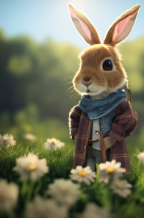

Gorgeous Crystal Palace, CG rendered European style, bird view, fairy tale, rose surround, lighting effects, sky, starry sky, super detail, illustration, 8K,4K, Unreal Engine, ethereal clouds are heart shaped, fantasy, HD--hd --ar 9:16

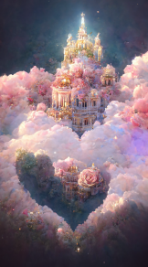

Gorgeous Crystal Palace, CG rendering European style, bird's eye view, fairy tale, rose surround, lighting, sky, starry sky, super detail, illustration, 8K,4K, Unreal Engine, ethereal clouds are heart shaped, fantasy, HD,--hd --ar 9:16

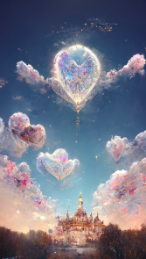

Dream and fairy flying moon Chinese style elegance, peach blossom + quiet + beautiful + high details, soft moonlight, Jade Rabbit, soft colors, soft lighting, 8K new happiness, deep details, clear layers, high quality, high definition and new love rendering HD--hd --ar 9:16

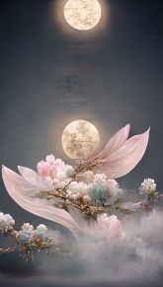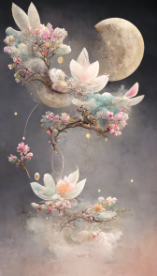

A spectacular waterfall, surrounded by roses, mysterious, bright, twinkling stars, movie lights, photorealistic, overlooking, high detail, surreal, mysterious, 8K, HD--hd --ar 9:16

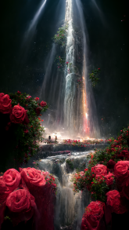

At the seaside, I want to see the scenery, want to chase the wind on the mountain, see the dusk and dawn, 3D, beautiful roses blooming on the sunset road, there are other shore flowers blooming, CG rendering, super realistic style description, dream, beautiful and romantic style, transparent ribbons floating in the air--hd --ar 9:16

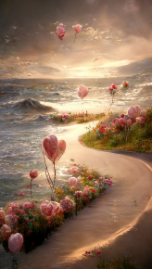

A beautiful picture depicts a train surrounded by pale pink roses. Lighting effects, on the top of the train has a lot of light blue roses, there are white clouds, the sky of soft cloud, rainbow and sunshine, hayao miyazaki painting, lifelike, fashion art, CG rendering, 8 k high definition, beautiful paradise, the 3 d effect, aesthetic illustrations, film aesthetics effect, crystal lamp, the AUV, 4 k post processing in detail, art, rendering by octane, Unreal Engine - Mass 1.5--hd --ar 9:16

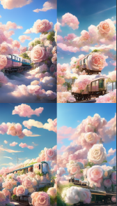

Cyberpunk Crystal Castle with Starlight and Roses - Test - Creative--hd --ar 9:16

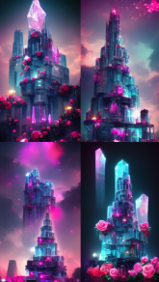

The highly detailed, stunning images of Neverland are ethereal, full of lights, and divine SONY Animation HD ultra detail--hd --ar 9:16

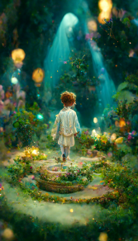

Under the night sky, the beach is covered with a large number of red crystal roses (16K), dark blue fairy roses, crescent moon, lights, fluorescent sea, moonlight on twinkling stars, Michael James Smith's matte painting, reflection, CG social selection, volume light, space art, bioluminescence, phosphor, unreal engine 5, magic of light, rendering in unreal engine, ultra wide angle of view, ultra wide angle of view, 16K HD picture HD --ar 9:16

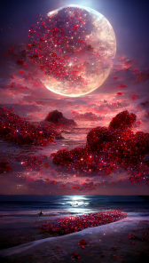

Cute white dog baby dressed like snow Queen, fluffy shiny temples, nine towers, snowflakes flying, anthropomorphic, Plexa-style, snow, 4K, Trends on ArtStation, Art Trends, Gorgeous, Ultra Wide Angle, 4K, Unreal Engine 5 and Octane Rendering, q2v3 Render --testp --ar 9:16



Luxurious palace, lighting, beautiful roses in front, crystal rose garden, ice blue leaves, layered, magic, realism, super detail, lifelike, 8K, 16K resolution, masterpiece, functional art station, octane rendering, panoramic, wide Angle, 3D, ice blue rendering, super realistic,--hd --ar 9:16

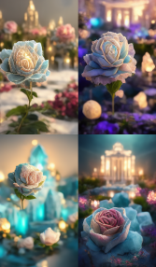

a beautiful detailed painting, a big fish swimming in the puffy clouds, sky with white lighting, overlook, dream, dark, bioluminescence, smooth fog, space galaxy, light effects, deep focus, depth view, 8K, HD, --ar 9:16 --q 2

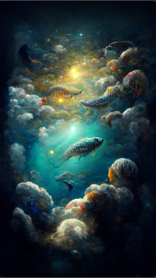

a glittering and translucent flower, colourful, anime style, kawaii style, hyper realistic, very detailed --ar 9:16

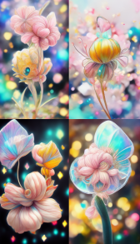

a beautiful detailed painting, a big koi swimming in the sky, the sky with clouds, overlook, dream, soft moonlight, smooth fog, space galaxy, light effects, deep focus, depth view, beautifully detailed, hyper realism, 8K, HD, --ar 9:16 --q 2

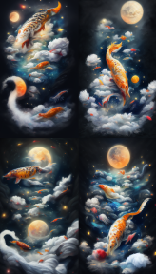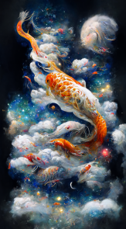

a beautiful detailed painting, a big live koi fly in the forest, there are many beautiful flowers on the ground, wide angle, dream, fairy lighting, smooth fog, depth view, intricate details, hyper realism, fantasy, octane rendering, 8K, HD, --ar 9:16 --q 2

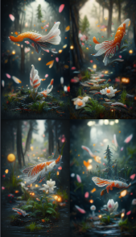

a beautiful detailed painting, a big live koi fly in the forest, there are many beautiful flowers on the ground, wide angle, dream, fairy lighting, smooth fog, deep focus, intricate details, hyper realism, fantasy, octane rendering, 8K, HD, --ar 9:16 --q 3

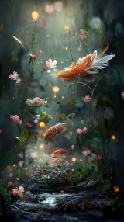

In the early morning, the dreamy sea is full of blue rose, among which there are glittering and translucent colorful blue rose and rainbow blue rose of different sizes, one petal and one color, and there are many water drops on the blue rose. Magical, natural lighting, wide angle, lighting effects and super details, 4K, HD --ar 9:16

